. Design the Functionalities and Exploration of TCP using Packet Tracer

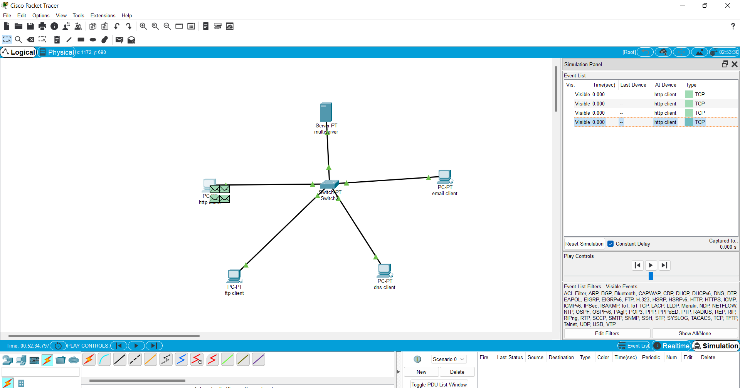

15. Design the Functionalities of Exploration UDP using Packet Tracer

